OS Lab 1
Date : 01/08/2025
Topic : Basics of UNIX commands and Implementation of Shell Programming

1. pwd : Print Working directory


2. cd : change directory

3. cd directory : change into the specified directory
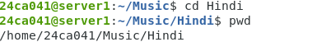

4. cd ~ : “~” is an alias for your home directory

5. cd .. : Move up one directory
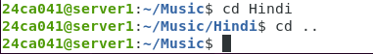

6. cd - : Return to previous directory


7. ls : List all files in the current directory, in column format
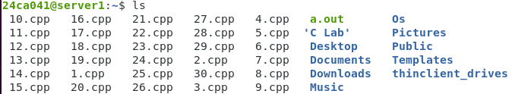
8. ls directory : List the files in the specified directory.

9. ls -l : List files in “long” format, one file per line. This
also shows you additional info about the file, such
as ownership, permissions, date, and size

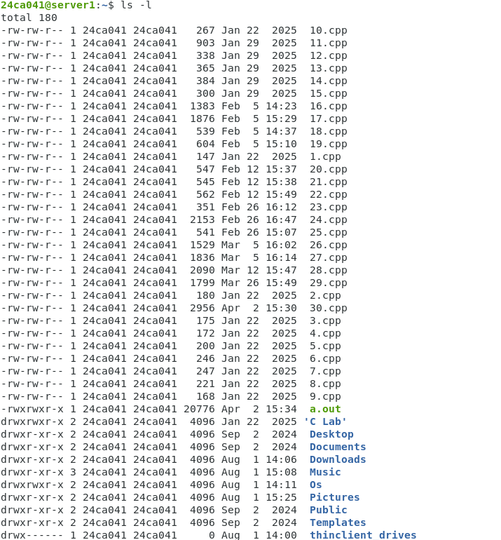

10. ls -a : List all files, including “hidden” files. Hidden files
are those files that begin with a “.”, e.g. The
.bash_history file in your home directory

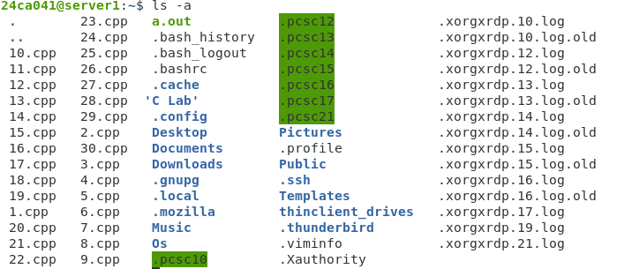

11. ls -ld directory : A “long” list of “directory”, but instead of showing
directory the directory contents, show the directory's detailed
information.

12. ls /usr/bin/d* : List all files whose names begin with the letter “d”
in the /usr/bin directory.

